Moving between PEMicro and MBED debugging

When I last used my Freedom KL25Z board, I was running programs compiled in mbed and then exported to Keil. When I plug my board in now, I see a DAPLINK(D:) drive:

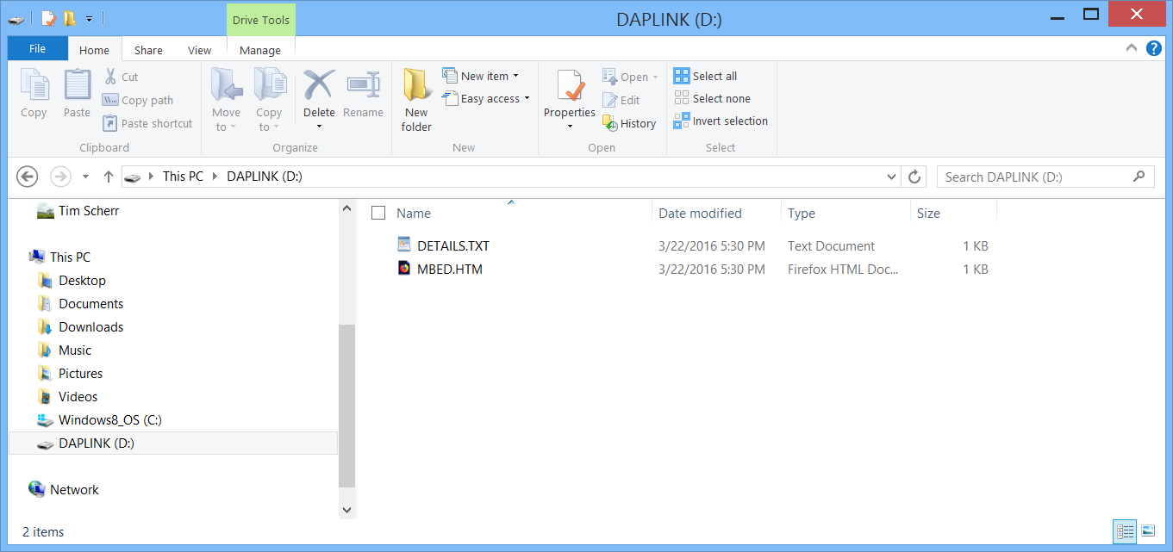

Double-clicking on the MBED.HTM file takes me to the mbed Freedom KL25Z webpage at <https://os.mbed.com/platforms/KL25Z/>

It used to be that the board would enumerate as drive labelled MBED, but at some point it became DAPLINK, which is consistent with the CMSIS-DAP Debugger in Keil. Having imported the mbed_blinky project into Keil I should be able to build and run the project in Keil. I could also use the mbed_blinky-KL25Z.bin file and copy it into this drive directly. This works and changes the LED from blinking green to blinking red.

Running Keil, building the project produces a scatter file location error. This is new, mbed didn’t used to have this problem. Fortunately it can be fixed quickly by using Project-> Target Options -> Linker and then selecting the down tab on the scatter file to select the correct path to it:

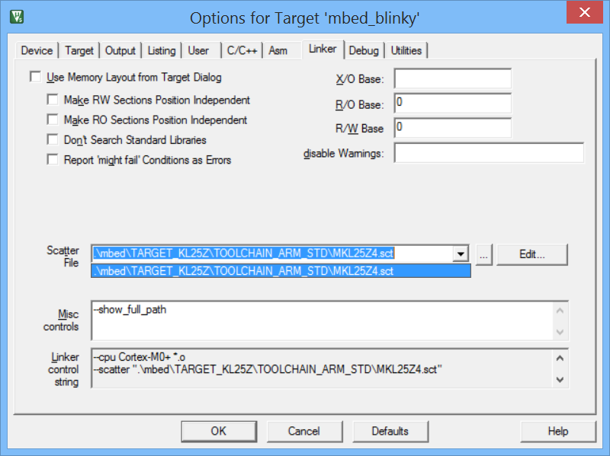

After this correction, the build completes with no errors, and once the Debug session is launched we see the program commencing in the debug window to the first line of main:

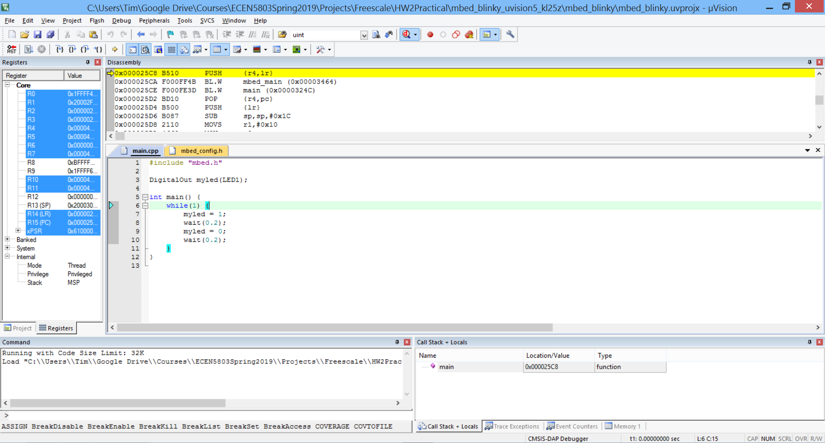

If we look at the disassembly window at address 0x00000000, we find the initial stack pointer is 0x20003000, and the initial Reset vector is 0x000002A1, and the initial PC is 0x0000 02A0:

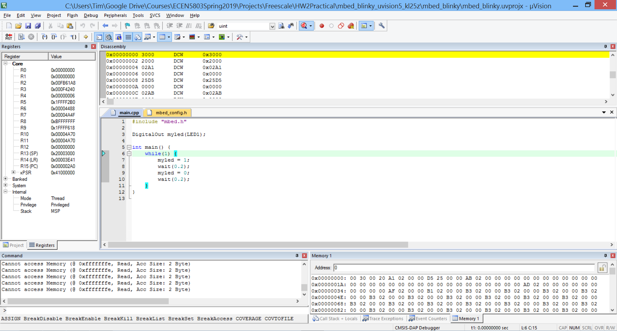

What if I wanted to debug using the PEMicro interface instead? One would have to replace the DAPLINK firmware with the PEMicro debug firmware. To do this, you must enter the bootloader mode by holding down the reset button in between the USB connectors, and then connect to the lower USB port:

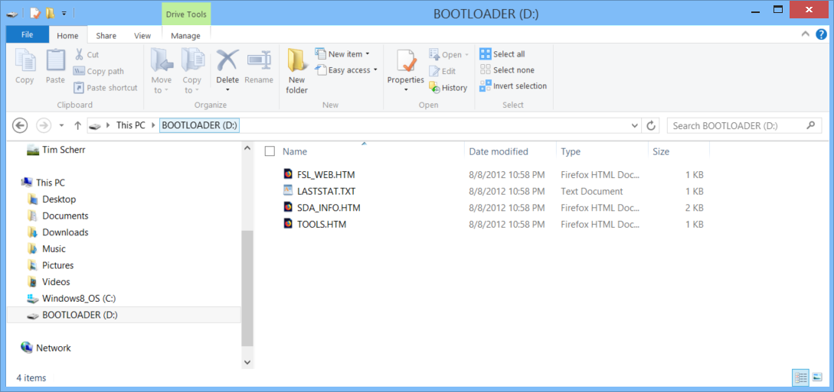

To install the PEMicro MSD debug OpenSDA application, use MSD-DEBUG-FRDM-KL25Z_Pemicro_v118.SDA and drag it to the BOOTLOADER drive. It should appear like this once the transfer is complete:

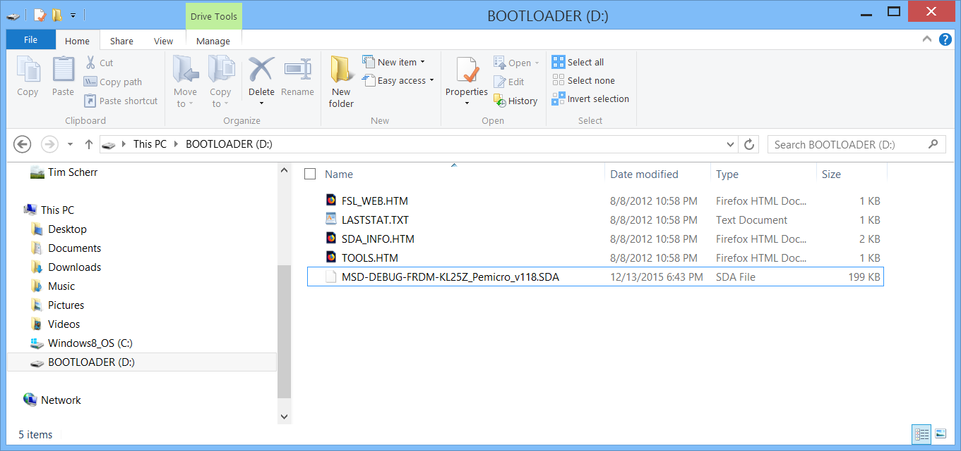

Unplug the USB and plug it in again. Now the board enumerates as FRDM-KL25Z:

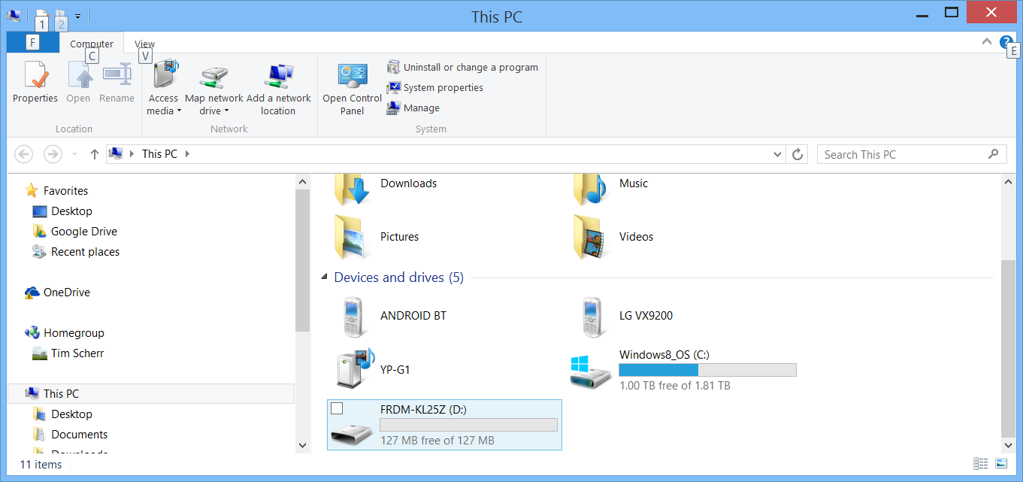

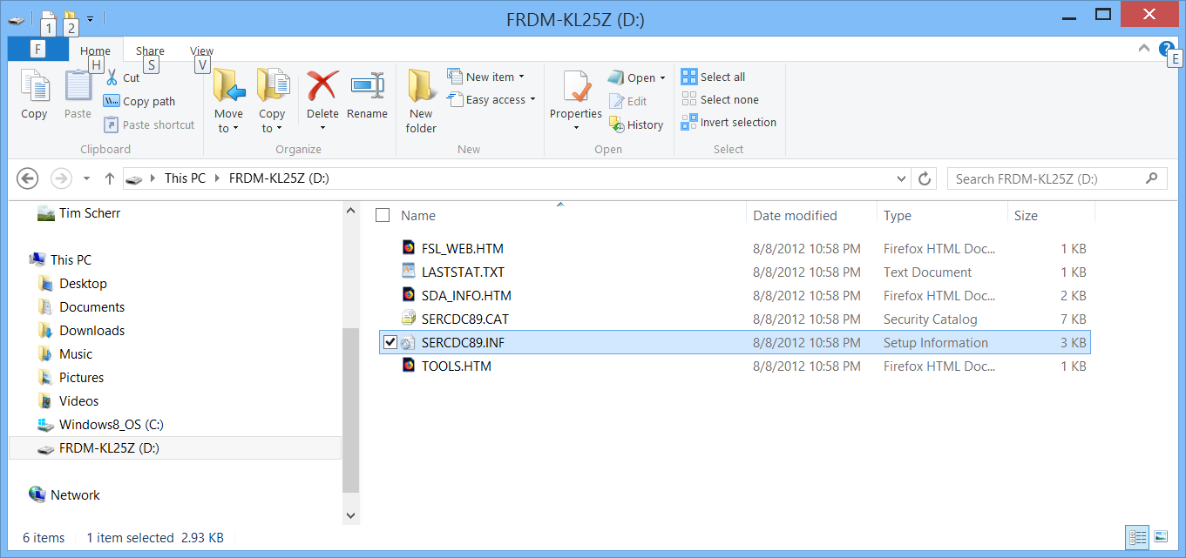

Double clicking on SDA_INFO shows that the application for Debug is now resident on the board:

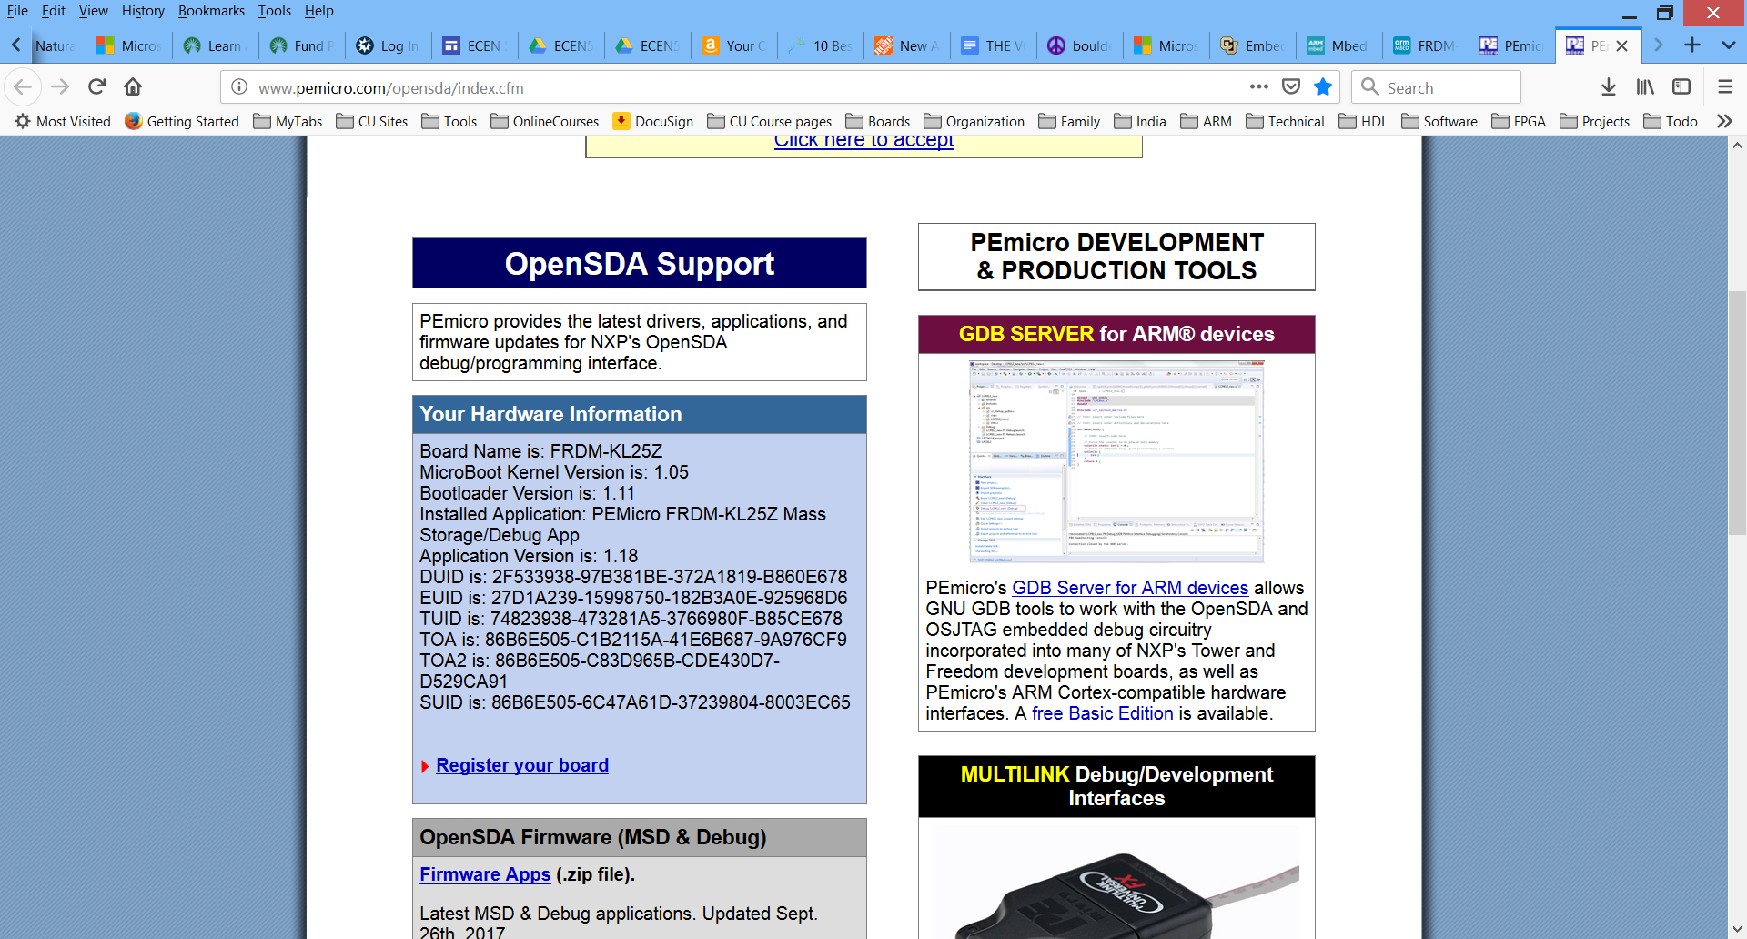

Now if you try to run with KEIL, the debug session won’t start, instead you get this error:

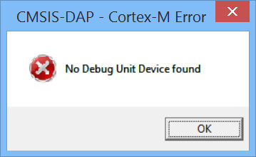

Because CMSIS-DAP is still selected. If you try to copy a bin file to the board, this still works however, and it shows up in the drive:

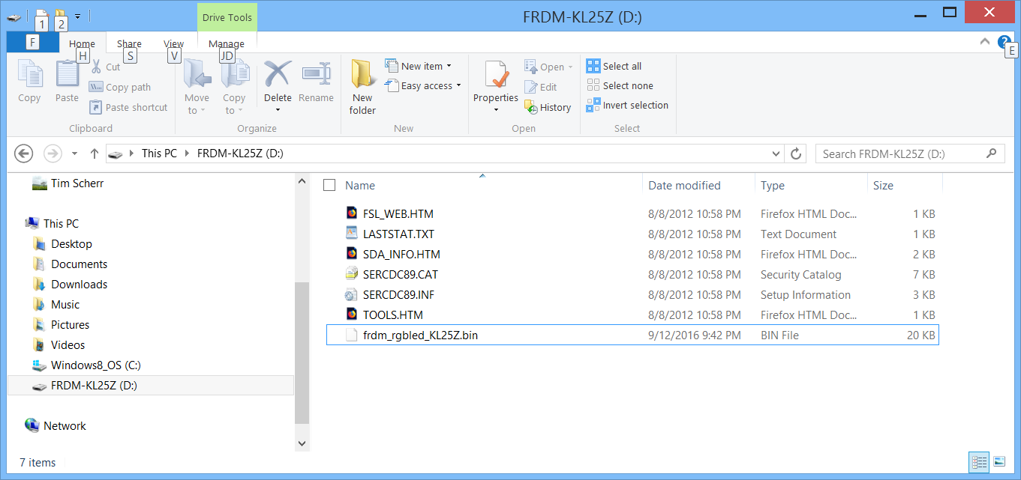

Now to get mbed blinky to run again, change the Debugger in KEIL from CMSIS-DAP to PEMicro:

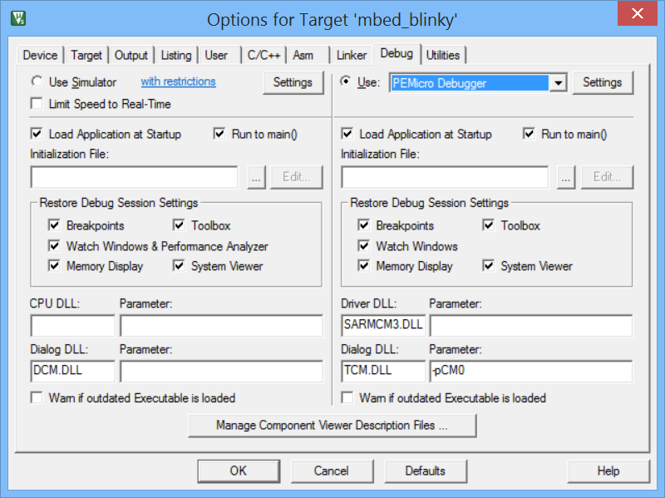

Click on Settings next to the PEMicro Debugger drop-down, then Select New Device and choose the KL25Z:

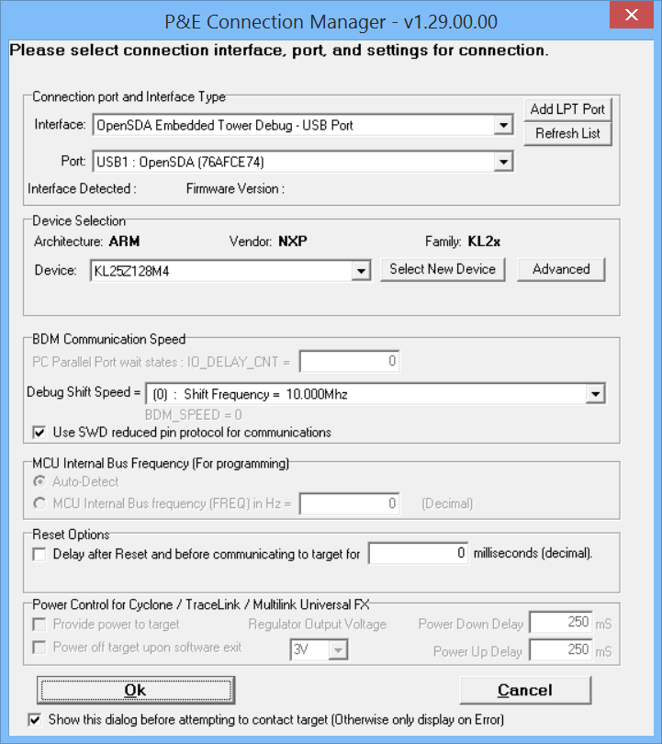

Also change the interface to OpenSDA – USB Port if it is not that already. Now we can start a debug session using the mbed_blinky project and it works just as before. But it is using the PEMicro Debugger, not the CMSIS-DAP debugger. What if we wanted to switch back to CMSIS-DAP?

When I copy the latest mBed firmware into the board in the Bootloader mode, file 20140530_k20dx128_kl25z_if_opensda.s19, I see the drive enumerated as mbed:

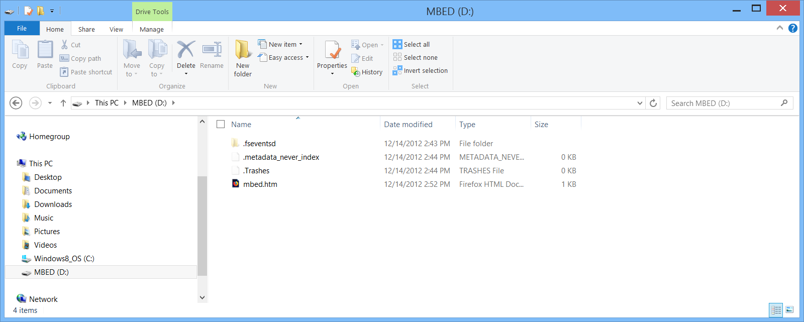

Now when I try to run the program in Keil using the PEMicro Debugger, it will not connect:

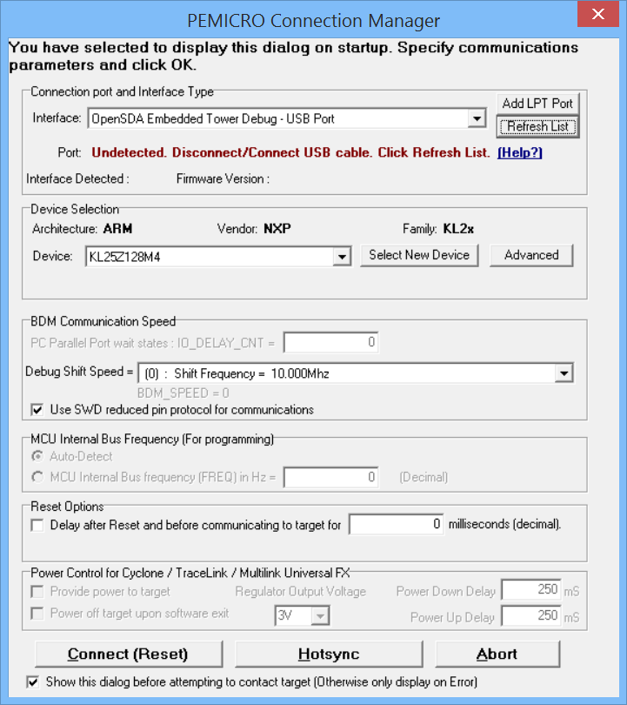

But when changed to CMSIS-DAP debugger option in Keil,

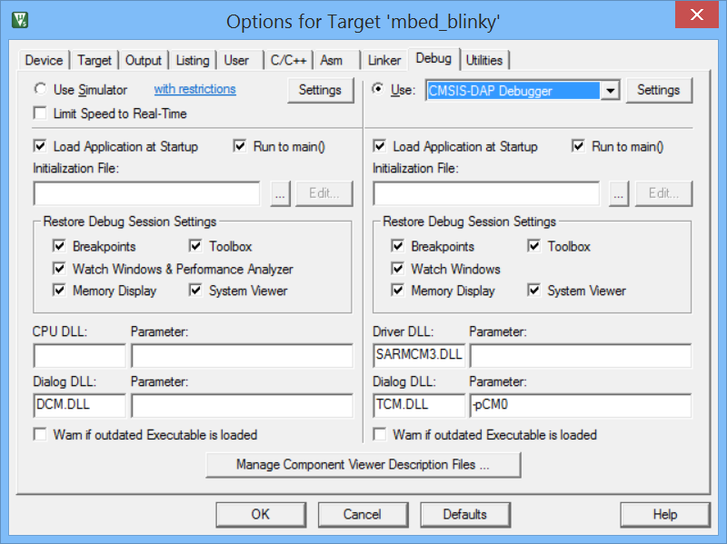

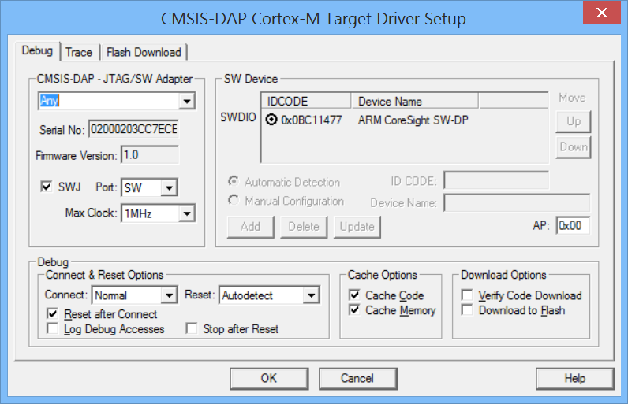

Then the code runs as expected and a Debug Session can start.

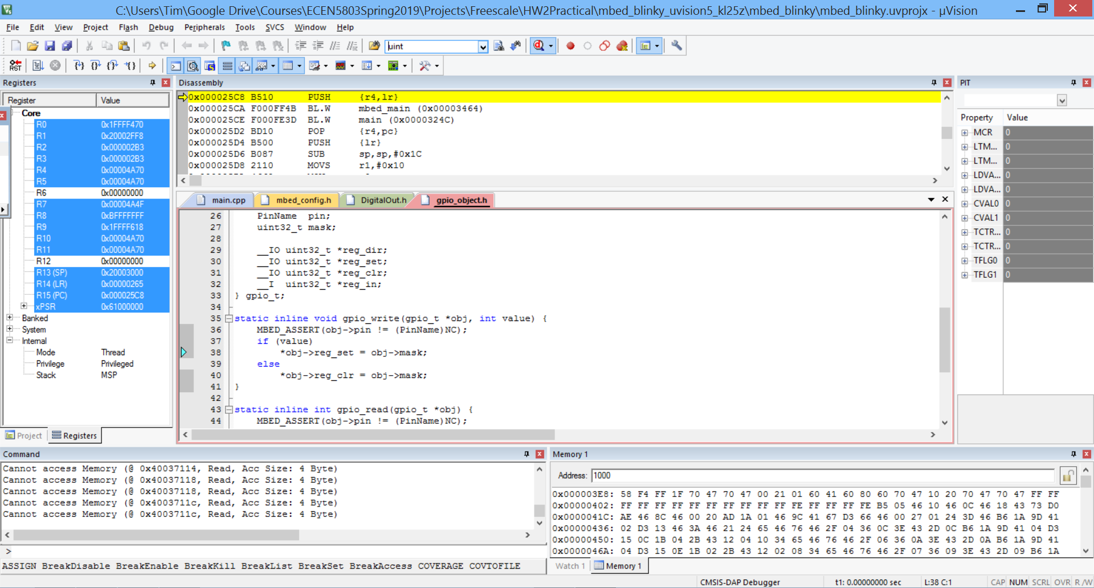

Sometimes as the board is plugged in, the MBED drive appears, but then disappears. This doesn’t effect the board’s ability to connect to Keil and run programs, however.

When the older Mbed firmware is installed, mbed_if_v2.0_frdm_kl25z.s19, the MBED drive still appears:

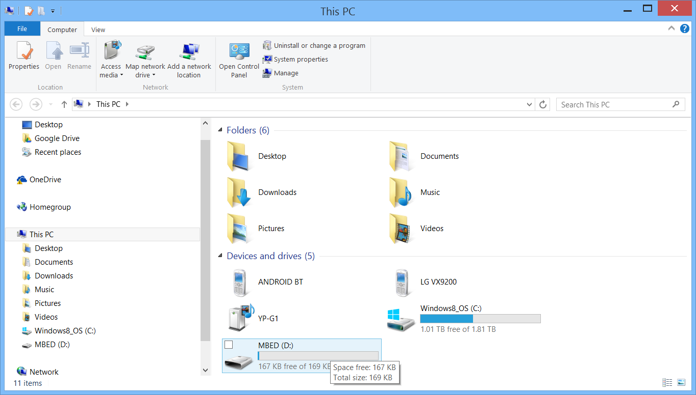

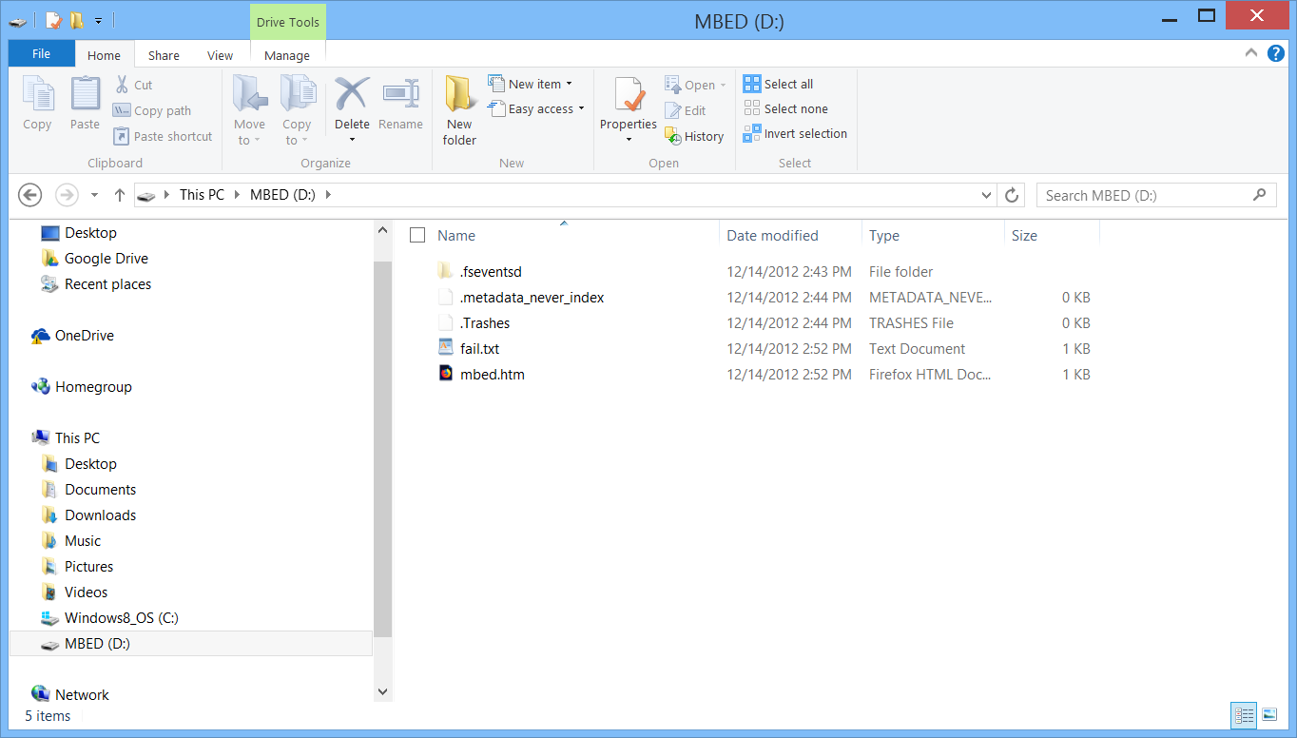

The file dates are now 2012 instead of 2014. This drive tends to disconnect as well, and is a bit more unstable. I am unable to get it to run programs from KEIL.

When I install the file CMSIS-DAP_OpenSDA.s19 from the OpenSDA applications directory, it does not enumerate, and does not run code from KEIL. I get the same result using the CMSIS-DAP.S19 file. These are much older files.

To get back to where I started, I install the latest DAPLINK file while in Bootloader mode, 0251_k20dx_frdmkl25z_0x8000.bin, and now the drive enumerates as DAPLINK:  
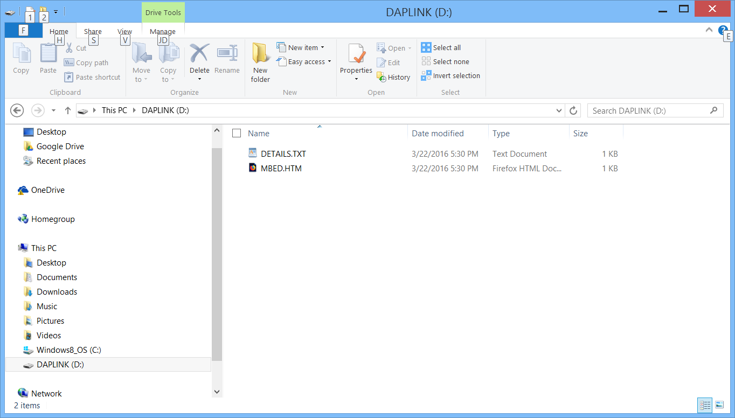

Again with MBED.HTM available. Programs loaded from KEIL with the CMSIS-DAP debugger run as before, and I am back to where I started from.